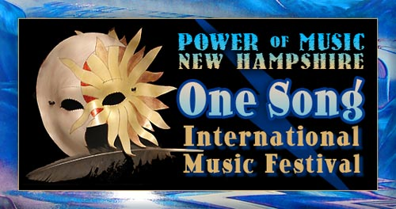
With Innovations for Humanity Summit, Exposition & Conference
powerofmusicnh.com
Event Director: B.Hughes 928-202-1447

Email form to: b@powerofmusicnh.com

Talent Show Sign-Up
Please include Bios or any prior success stories
Name(s):
Talent(s):
Age:
Phone:
Email:
Address:
Brief description of what you’d like to present:

